Apatity, Russia

27-30 November, 2010

All-Russia conference with
invited foreign speakers

Research and development in chemistry and technology
of functional materials
INVITATION
Circular 1

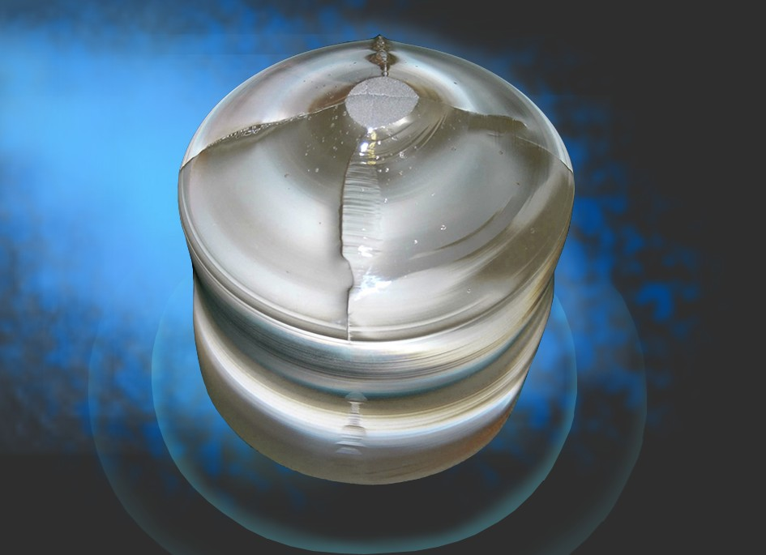

Russian Academy of Sciences

Russian Academy of Sciences
Department of Chemistry and Materials Science
Scientific Council on Chemical Technology of RAS
Scientific Council on Metallurgy and Physical Metallurgy of RAS
Murmansk region government
Kola Science Centre
I.V.Tananaev Institute of Chemistry and Technology of Rare Elements and Mineral Raw Materials

Оrganizing Committee

Chairman – Nikolaev A.I., Corr.Member RAS
(Apatity)
Members of the Organizing Committee:

Kalinnikov V.T., Academician RAS (Apatity)
Melnikov N.N., Academician RAS (Apatity)
Tigunov O.L., Vice-Governor of the Murmansk region
(Murmansk)
Olekhnovich N.M., Academician NAS of Belarus
(Minsk)
Avramenko V.A., Corr.Member RAS
(Vladivostok)
Prof. Sternberg A. (Riga)
Alymov M.I., Corr.Member RAS (Moscow)
Prof. Frolov A.A. (Kiev)
Prof. Dongfeng Xue (Dalian)
Gudilin E.A., Corr.Member RAS (Moscow)
Prof. W. Ryba-Romanowski (Wroclaw)
Prof. G. Dominiak-Dzik (Wroclaw)
Meshalkin V.P., Corr.Member RAS (Moscow)
Spivakov B.Ya., Corr.Member RAS (Moscow)
Kholkin A.I., Corr.Member RAS (Moscow)

Local Organizing Committee:

Chairman: Sidorov N.V., Dr.Sc. (Phys-Math)

Members of the Organizing Committee:

Zakharov V.I. , Dr.Sc. (Eng), Kuznetsov S.A., Dr.Sc. (Chem), Lokshin E.P., Dr.Ss. (Eng)

The Conference Secretariat:

Kalinkin A.M., Dr.Sc. (Chem), Chufyrev P.G., Ph.D. (Phys-Math)

The topics to be highlighted during the Conference:

- Chemistry of nano-particles, technology and methods for investigation of micro- and nano-structural materials
- Electrochemical and metallurgical processes for the production of advanced materials
- The raw material base and processing of complex minerals
- Technology of building materials. Waste recovery and analytical control. Economic aspects of the developed technologies

Conference Proceedings
The collected volume of the Conference Proceedings, both oral and poster presentations, will be available by the beginning of the conference.

Кey dates
15.04. 2010 | Submitting of applications
15.05.2010 | Sending of the 2nd Circular
15.05.2010 | Accepting of abstracts

Working languages
The working languages will be Russian and English

Registration fee
The registration fee is 800 Rb. This will cover the expenditures on publication of the Conference Proceedings, coffee breaks and cultural events. The fee can either be transferred to the conference account or paid upon registration.

Accommodation
The Conference participants will be accommodated in a recreation centre, and in the city and KSC hotels, offering different levels of comfort.

For further information, please address

Kalinkin Alexander Mikhailovich, Dr.Sc. telephone: (81555) 79523 E-mail: kalinkin@chemy.kolasc.net.ru ,
Chufyrev Pavel Gennadievich, Ph D. telephone: (81555) 79118, E-mail: chufyrev@chemy.kolasc.net.ru
fax: (81555) 79414; (81555) 76425

ICTREMRM KSC RAS, 26a, Academy premises 184209, Apatity, Russia

Рregistration form
to be submitted before April 15, 2010, at the address:
Kalinkin Alexander Mikhailovich, Dr.Sc. E-mail: kalinkin@chemy.kolasc.net.ru ,
Chufyrev Pavel Gennadievich, Ph D. E-mail: chufyrev@chemy.kolasc.net.ru

ICTREMRM KSC RAS, 26a, Academy premises 184209, Apatity, Russia
ICTREMRM KSC RAS, Conference

Surname
First Name
Position
Scientific degree
Affiliation

Fax
Telephone
E-mail
Title of the paper

Form of
presentation oral poster

Abstract submission

Abstracts for publication are to be submitted by e-mail as an attached file. When preparing the abstract, please take the following into account. The length is limited to two A4-size pages. The sequence of presentation is the following: title; the names of contributors with initials; affiliation; text of the abstract with included tables, figures and captions; list of references.

Sheet size — А4. Margins: upper — 1.5; lower — 1.5; left — 2.5; right — 1.5, from the edge to the running head — 1.25, to the running foot — 1.25.

Type — Times New Roman, for the text - — 10 pt font, for the title – 12 pt, bold, headlines in the centre, 10pt; subtitles- 10pt, bold italics. Spacing – single, indention of the first paragraph line – 1.0. Text layout – in width. All Latin and Greek letters in the text, formulas (except subscripts) and tables – in italics; numbers – Roman type.

Units of physical values. Please be guided by the SI system. The units are to be Roman typed (Pa, Wt/m², Joule/(kg·К) etc).

Numbers and signs in the text. One-figure numbers should be written in letters; great numbers - in letters and numbers, abridged (for instance, 20 th., 5 mln, 3 bln). The range of values should be written as: 17 – 20 mm, from 17 to 20 mm. The mathematical characters =, <, > etc. are to be used only in formulas. Within the text, the words “greater, smaller, equal to” should be used. As the decimal digit, a point is used (for example, 0.98).

The tables are to be numbered if they are more than one. The title is necessary, when the table is of primary importance; for subsidiary tables – no titles. Blank columns (with unavailable data) are to be marked by a dash. The tables are isolated from the text by one-line spacing. The table titles – in lowercase letters. The tables are to be created using the Microsoft Word Table. Entitled if the table is important and untitled if it is not.

Mathematical formulas. The formula is separated from the text by upper and lower horizontal blanks. The ordinal numbers are assigned to the major formulas referred to in the text; the numbers are put in round brackets at the right-side edge. Continuous numbering will be applied. The formula symbols are to be deciphered. The signs of mathematical functions (sin, ctg, arcsin, sh, Arsh, grad, rot, div, lim, exp, ln, lg) are in Roman type. The formulas, typed in font editors Microsoft Equation or MathType are to have the following character sizes: common subscripts — 10 pt, large subscripts — 6 pt, small subscripts — 4 pt, large symbols — 20 pt, small symbols — 10 pt.

The figures are to be numbered, if they are more than one. Instead of captions over the Figures, numerical or literal designations should be used, with elucidation in the caption under the figure. In addition, every figure (without the caption) should be submitted as an individual file. The formats recommended for the figure’s originals are BMP, JPG, TIF, PCX; resolution - — 300÷600 dpi; the caption font – 10 pt.

Abbreviations should be deciphered.

The list of references should fit the standard rules, given at the end, in the order of appearance in the text. Surname, First name – in clarendon, - 10 pt. No unpublished data should be referred to. The references in the text are to be given in square brackets, such as [1], [2, 3], [4 – 7].
The Organizing Committee

