Second Announcement and Call for Abstract

INTERNATIONAL CONFERENCE ON PHYSICS
OF LOW TEMPERATURE PLASMA PLTP-03
Kyiv, Ukraine
May 11-15, 2003

Related Events

Seminar on Technological Applications of Plasma
Workshop on Application of the Low Temperature Plasma in the Power Engineering

Due to the fact that the applications for participation in the Conference have continued to come during whole January, the registration and materials submission terms have been extended.
As a consequence of conference preparation brief terms the materials will be furnished mostly via E-mail

Conference Organizers
National Academy of Sciences of Ukraine (NASU)
Russian Academy of Sciences (RAS)
RAS Scientific Council "Physics of Low Temperature Plasma"

State Committee of Ukraine for Energy Conservation
Ministry of Fuel and Energy of Ukraine (MFEU)
Ministry for Education and Sciences of Ukraine
Ministry for Industry and Science of Russian Federation
Committee on Energy Efficiency of the Council of Ministers of the Republic Belarus
Kyiv City State Administration

Kyiv National Taras Shevchenko University
Institute for High Energy Densities, Associated Institute for High Temperatures RAS
NASU the Gas Institute
NASU Institute for Theoretical Physics
NASU and MFEU Institute for Power Coal Technologies
Heat and Mass Transfer Institute of the National Academy of Sciences of Belarus

Deadlines
Pre-registration ______________________________________________  Second announcement and call for abstract ________________________  Announcement for accommodation ______________________________  Abstract submission and registration _____________________________  Acceptance notification and call for paper_________________________  Applications for participation in the seminar and workshop___________  Registration fee payment ______________________________________  Final program _______________________________________________  Full paper transmission _______________________________________ | February 5, 2003  February 25, 2003  March 15, 2003  March 15, 2003  March 25, 2003  March 25, 2003  April 10, 2003  April 20, 2003  May 11, 2003

International Organizing Committee

V.E.Fortov (co-chairman), Russia

A.K.Shydlovsky (co-chairman), Ukraine
V.S.Vorob’ev (vice-chairman), Russia
V.A.Zhovtyansky (vice-chairman), Ukraine
V.D.Shimanovich (vice-chairman), Belarus
Eu.V.Martysh (scientific secretary), Ukraine

International Program Committee

Yu.P.Korchevoy (chairman), Ukraine  A.F.Alexandrov, Russia  I.O.Anisimov, Ukraine  S.I.Anisimov, Russia  V.I.Arkhipenko, Belarus  E.I.Asinovsky, Russia  V.M.Astashinsky, Belarus  V.M.Batenin, Russia  M.S.Benilov, Portugal  V.S.Burakov, Belarus  G.Van Oost, Belgium  T.O.Davydova, Ukraine  S.V.Denbnovetsky, Ukraine  G.A.Dyuzhev, Russia  V.A.Zhovtyansky, Ukraine  A.G.Zagorodny, Ukraine  A.N.Zolotko, Ukraine  I.M.Karp, Ukraine  G.S.Kirichenko, Ukraine  Yu.D.Korolev, Russia  A.S.Koroteyev, Russia  S. Kuroda, Japan  M. Laan, Estonia  V.I.Lapshyn, Ukraine  Yu.A.Lebedev, Russia | F.C.Lockwood, UK  Ma Tengcai, China  G.E.Norman, Russia  V.M.Mal’nev, Ukraine  A.L.Masse, Belarus  V.E.Messerle, Kazakhstan  G.A.Mesyats, Russia  J.Mizeraczyk, Poland  P.Misaelides, Greece  A.B.Murphy, Australia  O.F.Petrov, Russia  O.D.Pogrebnyak, Ukraine  L. Pranevicius, Lithuania  T.S.Ramazanov, Kazakhstan  J.P.Riviere, France  F.G.Rutberg, Russia  M. Sadowski, Poland  I.O.Soloshenko, Ukraine  A.N.Starostin, Russia  P.Stefanovic, Yugoslavia  V.I.Tereshin, Ukraine  Yu.N.Tyurin, Ukraine  V.S.Filinov, Russia  Yu.P.Shcherbak, Russia  K.Yatsui, Japan

Local Organizing Committee

V.A.Zhovtyansky (chairman)  V.P.Gondyul (vice-chairman)  A.N.Gurzhiy (vice-chairman)  V.A.Kir’yan (vice-chairman)  O.A.Goncharov  O.V.Dytynenko  M.L.Zhatkevych  T.S.Zhurbenko  O.Yu.Kravchenko  Yu.P.Kukota | Yu.G.Kutsan  T.E.Lisitchenko  O.Yu.Maystrenko  Eu.V.Martysh  S.V.Petrov  G.A.Frolov  M.M.Khvorov  V.Ya.Chernyak  K.P.Shamrai

General Information

International Conference on Physics of Low Temperature Plasma will be held in the Great Conference Hall, the National Academy of Sciences of Ukraine, Kyiv, May 11-15, 2003, following the Conference on Physics of Low Temperature Plasma, Petrozavodsk, Russia, 2001. Prof. N.D.Morgulis (T.G.Shevchenko Kyiv University) organized the first conference in Kyiv in 1966 as All-Union Conference on Low Temperature Plasma.

The conference covers all the area of low temperature plasma and its applications. Its aim is to present the recent progress in this field.
The Conference will be organized in plenary lectures, a series of parallel oral sessions (with invited and contributed papers) and poster sessions. Seminar on Technological Plasma Applications and Workshop on Application of the Low Temperature Plasma in the Power Engineering will be held during the Conference.

Conference Sessions

1. Plenary Session
2.  3.  4.  5.  6. | Plasma Diagnostics  Low Temperature Plasma Application in  New Technologies  Kinetics of Low Temperature Plasma Thermal Physics, Optics and Transport  Phenomena in Plasma  Near-Electrodes Processes in Plasma | 7.  8.  9.  10.  11.  12. | Gas Discharge  Non-Ideal Plasma  Dusty and Cluster Plasma  Kinetics and Dynamics Processes of the  Burning  Collective Processes in Plasma  Industrial Application of Plasma

Take a note, please! The Section “Elementary Processes in Plasma ” (represented in the Preliminary List of Topics) was excluded from the List due to the absence of the submitted Contribution papers in result of the preliminary registration of the participants.

Please indicate in the attached Abstract Submission Form the identification number of the session, where you prefer to include your contribution

Language

The official language of the Conference is English. In special cases the translation service will be available.

Invited Lectures

Plenary Sessions

Yu.S.Akishev, A.P.Napartovich, N.I.Trushkin  (Russia)  N.L.Alexandrov, E.M.Bazelyan, Yu.P.Raizer  (Russia)  F.G.Baksht (Russia)  L.G.D’yachkov, V.G.Nikiforov, V.S.Vorob’ev  (Russia)  V.E.Fortov (Russia)  M.Hrabovsky (Czech Republic) | I.D.Kaganovich (USA)  V.I.Karas’ (Ukraine)  V.I.Lapshyn (Ukraine)  K.P.Shamrai, G.S.Kirichenko, V.F.Virko  (Ukraine)  B.M.Smirnov (Russia)  A.Zagorodny, V.Zasenko, J.Weiland  (Ukraine-Sweden)  V.A.Zhovtyansky (Ukraine)

Topical Sessions

I.O.Anisimov, L.I.Romanyuk (Ukraine)  G.A.Frolov (Ukraine)  I.Gerasimov (Russia)  O.A.Goncharov (Ukraine)  Yu.P.Korchevoy (Ukraine)  Yu.D.Korolev (Russia)  Yu.A.Lebedev (Russia)  V.M.Mal’nev (Ukraine)  A.L.Masse (Belarus) | O.Yu.Maystrenko (Ukraine)  V.E.Messerle (Kazakhstan)  A.D.Podgorny, Yu.N.Tyurin (Ukraine)  I.Ya.Sigal (Ukraine)  B.S.Soroka (Ukraine)  K.L.Stepanov (Belarus)  T.S.Ramazanov (Kazakhstan)  B.A.Uryukov (Ukraine)

Seminar on Technological Applications of Plasma
(Co-chairmen Prof. Yu.A. Lebedev, Prof. V.E. Messerle, Prof. A.D.Podgorny,
Prof. Yu.N.Tyurin)

The topics will be focused on cold and thermal plasmas current and possible industrial applications. All contribution will be mainly given by scientists from well-known institutions and companies.
A specific registration fee for Seminar is required and it will include the Book of proceedings of the Seminar and coffee break.

Workshop on Application of the Low Temperature Plasma in the Power Engineering
(Co-chairmen Prof. V.E.Messerle, Dr. Sci. V.A.Zhovtyansky)

The problems of the thermal plasma industrial applications in the Power Engineering will be discussed. The Workshop will pass in form of “round table” involving participation of the leading scientists and specialists dealing with the issues world-wide.
The participation in the Workshop on Application of the Low Temperature Plasma in the Power Engineering for non-industrial organizations is free of registration fee but the amount of participants is limited .
Additional information on the Seminar and Workshop will be available in March

Program

Registration of participants at the Conference will start on Sunday, May 11th, 2003. The scientific program will be started with the opening ceremony on Monday, May 12th, 2003 morning and will be closed on Thursday, May 15th, 2003 afternoon.

Call for Papers and Abstracts Submission
Abstracts of invited lectures as well as of contributed papers are welcomed from all the participants of Conference.
A4 single-page abstracts of contributed papers and up to 3 pages abstracts of invited lectures should be submitted to PLTP-03 Scientific Secretariat till of March 15, 2003. Abstracts of contributed papers are to be submitted for a review by the International Program Committee. The abstracts should be written in English according to the instruction given in the abstract template attached to this announcement, available also on www.necin.gov.ua. They must include: author’s names and their affiliations, e-mail for sending the reviewed results, title, topic number, preference concerning oral or poster presentation. The one page of abstract should include no more than 2 figures and be of full-page volume.
Please submit copy of each abstract with attached Abstract Submission Form by e-mail. Faxes will not be accepted.

Abstract template is available in addendum to this announcement and on www.necin.gov.ua

The final term for receipt of abstracts are:
contributed papers - March 15, 2003
invited lectures - March 25, 2003

E-mail submission is possible to E-mail: pravo@necin.com.ua

Abstracts of contributed papers will be reviewed by the International Program Committee on their delivery. About 100 contributions will be selected for oral presentation; all other accepted contributions will be presented in form of poster.
It is essential that abstracts would state concisely, but informatively, the objectives, methods, principal findings, and significance of the work to be presented. The authors are responsible for the content and style of contributions. The abstracts should not need any editing or retyping by conference organizers.

Proceedings

The conference abstracts will be collected and printed before the Conference. Proceedings including full-length papers (up to 6 pages for contributed one and up to 10 pages for invited lectures) will be collected at the Conference and printed later.

No abstract will be published, unless the registration fee is received from one of the authors within April 10th, 2003.
The Proceedings will contain only papers presented at the Conference by one of the authors.

Registration Fee
The registration fee of 250 US$ includes the participation in the Conference, a copy of the Book of abstracts and Proceedings. It also includes coffee breaks, welcome cocktail party and tour.
The registration fee for accompanying person equals 80 US$ covering coffee breaks, welcome cocktail party and excursion.
The registration fee will be reduced for students up to 30 US$. For participants from countries with transient economics the registration fee will be reduced according to purchasing power parity. Students should send a letter of their advisor attesting their status along with the payment of registration fee.
Registration forms will be available in March
A specific registration fee is required for the Seminar on Technological Applications of Plasma and includes coffee break and the Book of proceedings of the Seminar.
Accommodation
There will be good choice for the participants’ accommodation: from comfortable rooms in University hostels ( about 5 US$ cost) to good (****) hotels in the center of city (about 100US$ cost) per diem.
Detailed information on the participants’ accommodation will be given in the middle of March

Visa
Participants who need a visa to enter Ukraine should contact Ukrainian Embassy or Ukrainian Consulate well before PLTP-03. Since an invitation letter is sometimes required for visa procedure, please indicate in the Registration Form if you need it. It would be preferable to start the visa procedure in proper time to avoid any possible delays related to obtaining of the visa.
Travel Information
Participants can get to the city of Kyiv (Russian transcription - Kiev) by airplane, by train and auto (bus). There are several Ukrainian Air companies which propose their services to foreign visitors willing to get to the city of Kyiv, the capital of Ukraine. Other popular air companies are KLM (via Amsterdam), Austrian Airlines (via Vienna), Luftganza (via Frankfurt on the Mine). International Airport Borispol is located in 50 km from Kyiv and proposes wide range of traffic service to get to different places within the city, including bus, mini-bus and taxi.

Venue
The conference will take place in Kyiv in the Great Conference Hall, National Academy of Sciences of Ukraine. Kyiv is the capital of Ukraine and one of the oldest city in the Central and Eastern Europe (here in Ukraine the center of Europe is located). The city is mentioned in ancient chronicles in connection with the St. Andrew pilgrimage to eastern lands. From the IX century Kyiv is mentioned as mother of Russian cities and from the end of the X century has became one of the world centers of the Orthodoxy. Being located on the hills of the river Dniper, the City has unique picturesque landscapes and a lot of places of interest, which are worthwhile of seeing them. Kyiv is especially beautiful in May, when the Conference will be held.

Social Events
The Local Organizing Committee will propose a number of social events for participants. The social program will include a welcome cocktail party and tours.
Program of tours will be available in March

Conference web site: www.necin.gov.ua
E-mail: emart@mail.univ.kiev.ua (Scientific Secretary)
pravo@necin.com.ua (Office)

Addendum

Instructions for authors of abstracts
to be presented at International conference on physics of low temperature plasma PLTP-03
Kyiv, Ukraine, May 11–15, 2003

See the Example formatting abstracts.

Your paper should include:
- Title
- Authors & affiliation
- Text of abstract
- Abstract may include figures and tables and Reference section (bibliography).

The volumes of the abstracts consist of one full page A4 for contributed papers and up to 3 pages for invited papers.
Abstracts should be submitted to PLTP-03 Secretariat within March 15, 2003 for contributed papers and within March 25, 2003 for invited papers.
It is recommended to send the abstract in electronic form using the E-mail: pravo@necin.com.ua.
Acknowledgments will be communicated to the contacting author. The author should indicate in Abstract form whether an oral or a poster presentation is preferred, and which session the contribution should appear in.
Submitted abstracts will be reviewed by the Organizing Committee for their being in theme with the Conference, and for their scientific quality. The Organizing Committee will also decide for oral or poster presentation. Acceptance or rejection of the abstract will be notified to the author within March 25, 2003.
The abstract of the contributed papers must be in English and should report previously unpublished work. The authors are responsible for the content and style of the contribution. No editing or re-typing will be carried out by the Conference organizers.
The electronic copy of your paper must be MS Word document, a Rich Text file (RTF) or portable Document Format (PDF). The abstract should be typewritten for A4 formats paper (210x297 mm). Top and bottom margins should be set to 2,5 cm, left and right margins to 2 cm. Single-line spacing should be used.
Please use the Word templates provided when producing your abstract. This is an empty Word file (PLTP-template.doc) with pre-formatted styles such as “PLTP-Title”, “PLTP-Author”, “PLTP-Address” and “PLTP-Body”.
If you use a MathType or similar specialised software which allows export of equations as images, please export equations as EPS files (or LaTeX) and send each equation as a separate file as well.
Equations must be centered and numbered on the right as the following one:
K(t)=b³·Pi/(exp(a²–bx) (1)
Fonts must be:
Title: Times 14, Bold, centered, caps
Authors names: Times 12, normal, centered
Affiliations: Times 10, Italic, left
Main text: Times 10, justified in left and right
Figures and tables caption: Times 10, normal, centered
List and number all references at the end of the Abstract. When referring to them in the text, type the corresponding reference number between brackets as shown at the end of this sentence [1].
1. A. Author, B. Co-author, D. So On. — Park City. 25, 525 (2002).
place your title here
Example of formatting abstracts
Please always use the pre-formatted styles given in this document, such as
PLTP-Heading PLTP-Body etc. (See the instructions).
(times 14, bold, centered, caps [PLTP-Title])

A. Author¹, B. Co-Author², D. So On². (Times 12, normal, centered [PLTP-Author]).

1 Department of Nuclear Physics, Moscow State University, Moscow, Russia (Times 10, italic, left [see the style PLTP-Address])
2 Department of Thermal Plasmas, Institute of Plasma Physics, Praha, Czech Republic

1. Introduction (Times 10, bold, left [PLTP-Heading])
The free-burning electric arc between evaporated electrodes is suitable device as a source of dense plasma. It investigations are also connected with modern commutating devices creations. In such type of arc the evaporated due to current electrodes material hits into the electrodes gap. Having low ionization energy in comparison with atoms of ambient gas (as a rule noble, air), metal vapour makes basic contributions into the established electron density. As a result it plays a key role in the processes of a heat, mass and charge transfer in plasma. Thus, the basic parameters of electric arc are wholly determined by dirt of electrodes material. (Times 10, normal, justified in left and right [see the style PLTP-body]).
2. Experimental technique
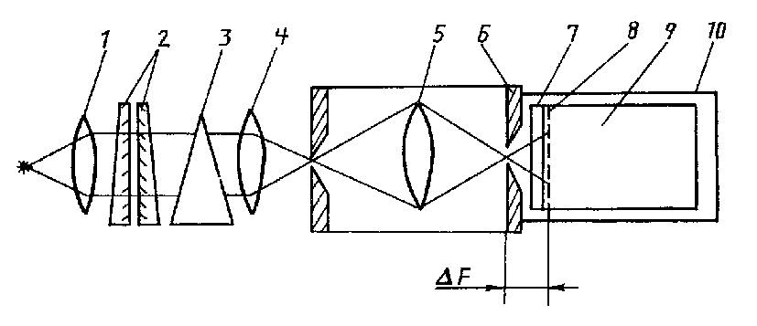
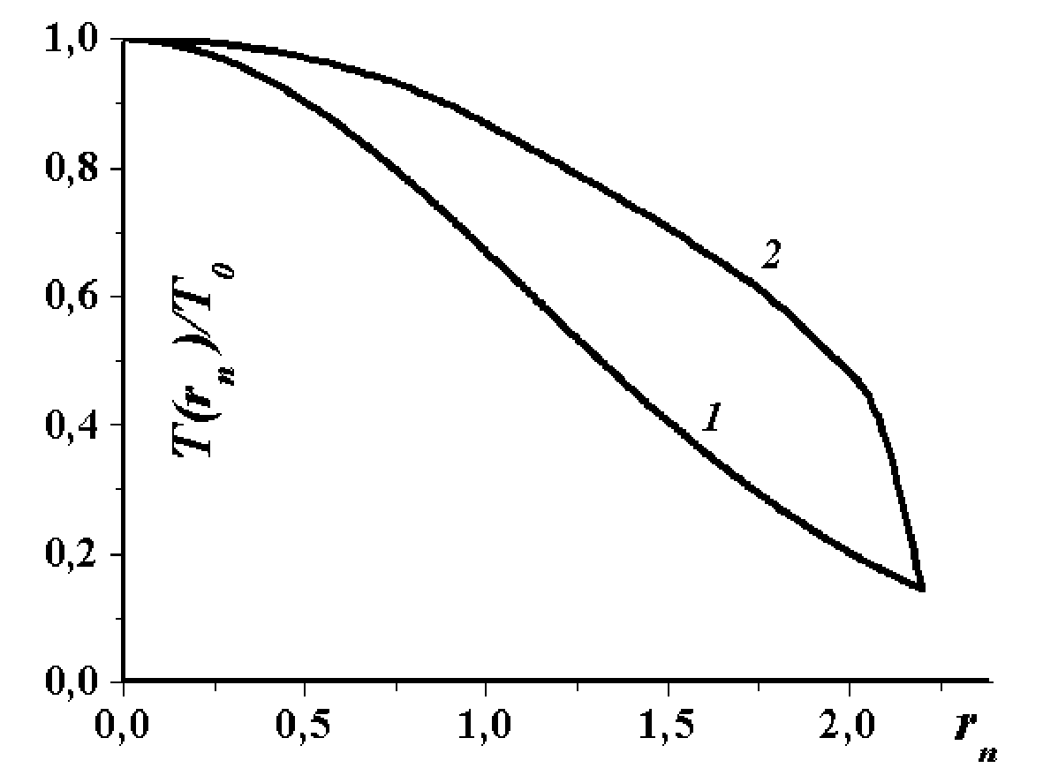
The principal peculiarity of the tomographic spectrometer is using of the optical system having difference ΔF in sagittal focus F_{s}, and meridional one F_{m} (Fig. 1). It allows to employ in this device any wide-aperture monochromator without limitation on astigmatism and image sensors of arbitrary type. A Fabry-Perot interferometer is used to give high spectral resolution. The interference pattern at the output contains information on the line shapes and the radial distribution, so it is not necessary to make repeat scans on the diagnostic is based on the line shapes. Tomographic spectrometer consists of: 1) collimator; 2) Fabry-Perot interferometer; 3) Dovet prism; 4) objective; 5) monochromator (shown schematically); 6) output slit; 7) dissector window; 8) photocatod; 9) dissector; 10) housing for dissector unit.
Fig. 1. Tomographic spectrometer
Fig. 2. Radial normalized temperature profiles T(rn)/T₀
3. Diffusion of copper electrodes erosion products in electric arc
Here the correction factor k_{w}=[1-exp(-x_{w}²)]⁻¹ is presented in order to make equal copper inflow into the arc in the cases of approximation w_{Cu} with the expression (1). With the increasing of x_{w} it decreases exponentially to the volume k_{w}=1 and when x_{w}>2 it can consider to be equal 1 with satisfactory accuracy. In both cases w₀ equals $2G/\left({πr}_{а}^{2}L\right)$. The distribution of cooper along electric arc is considered as homogeneous. It is due the fact that the rate of copper extension is determined by diffusion coefficient, which is larger in the channel due to the high temperature. As it is shown in [1] the result of calculations practically identical with the variation of r_{s} within r_{s}<r_{a}, therefore it is considered that r_{s}=r_{a}.
w_{Cu}=k_{w}w₀exp(-r²/r_{s}²), (1)
References [This is style PLTP-Heading]
- A. Author, B. Co-author, D. So On. — Park City. 25, 525 (2002).
Endnotes [This is style PLTP-Heading]
If you use endnotes, please place them before the acknowledgements (the style [PLTP-Body]).
Acknowledgements [This is style PLTP-Heading]
Please place this section at the very end of the paper (the style [PLTP-Body]).
International conference on physics of low temperature plasma PLTP-03
Kyiv, Ukraine, May 11–15, 2003

ABSTRACT-FORM

Author Contacting Details

Mr. |  | Ms.
Family Name……………………………………………………………………………….……
First Name……………………………………………………………………………………….
(Patronymic)..……………………………………………………………………………………
Title………………………………………………………………………………..…………….
Institute/Company……………………………………………………………………………….
Address……………………………………………………………………………..……………
Zip Code……………………………………………………………………………..…………..
City……………………………………………………………………………..……….……….
Country……………………………………………………………………………..……………
Phone……………………………………………………………………………..…….………..
E-mail……………………………………………………………………………..……………..
Fax……………………………………………………………………………..………………....

Title of the paper
…………………………………………………………………………………………………...
……………………………………………………………………………..…………………….

Topics of PLTP-03

Topic №: _________

Preference for presentation

 | ORAL |  | POSTER (mark one)

Deadline for submission
The deadline to submit abstracts for reviewing by the Organizing Committee are:
– March 15, 2003 for contributed papers,
– March 25, 2003 for invited papers.

Paper acceptation
The acceptation of the contribution will be sent by mail (E-mail), March 25, 2003, to the author indicated above.

Abstract
See Instruction for authors with example attached in this form.
3 copy when sent by mail, or one single file (1 page for the form, 1 page for the abstract), when sent by E-mail. Please return this form with abstract by E-mail before March 15, 2003 to Organizing Committee — pravo@necin.com.ua.

Presenting author………………………………………………………………………….…...
Co-Authors………………………………………………………………………….…………

Attention: Abstracts submitted via fax will not be considered!

